

2024 KAMSS

Educational

Conference

June 13th – 14th

Drury Plaza Hotel

Wichita, KS



**Thursday, June 13**

**7:00am Registration & Continental Breakfast in the Mezzanine**

Breakfast will be in the hotel Mezzanine. This is a hot breakfast that could include Belgian waffles, fruit, biscuits & gravy, and more.

**7:50am- 8:00am Welcome**

**8:15am- 9:45am Medical Staff Governance (1.5)**

**9:45am- 10:00 am Break**

**Thursday, June 13**



**7:00am Registration & Continental Breakfast in the Mezzanine**

Breakfast will be in the hotel Mezzanine. This is a hot breakfast that could include Belgian waffles, fruit, biscuits & gravy, and more.

**7:50am- 8:00am Welcome**

**8:15am- 9:45am Medical Staff Governance (1.5)**

Provide an overview of the self-governing organized medical staff CMS and Joint Commission regulatory requirements and tools. We will discus strategies for insuring strong, interlocking governance improvements and its impacts on impowering the medical staff.

**9:45am- 10:00 am Break**

**10:00 am-11:30 am Credentialing and Provider Enrollment: Two Sides of the Same Coin – Are you Heads or Tails? (1.5)**

Are you hearing the word “credentialing” being used differently by people these days? There are many functions coming under the umbrella of credentialing but maybe we need to look at the similarities and differences of the functions. This program will review the functions of traditional credentialing and provider enrollment, compare and contrast the tasks and suggest ways that working together may not only enhance the two processes, but could offer some new job opportunities.

**11:30am- 12:00pm NAMSS Representative Anne Wynne (.5)**

**12:00 to 1:00 pm Lunch and Presentation of Excellence in Service Award**

**1:00pm- 2:30pm Speak Up – It’s Your Job – identifying and addressing Red Flags (1.5)**

It’s one thing to collect data related to an application or reapplication. It’s another to be able to identify some of the “flags” raised when assessing that information once received. The more you experience you have processing files, the more you develop a “sixth sense” to know there’s something not quite right. This session will identify common and uncommon red flags that should be addressed and steps to take depending upon the nature of the information received.

**2:30pm- 2:45pm Break**

**2:45pm- 4:15pm Navigating Physician Aging and Physician ReEntry – Tricky but Doable (1.5)**

There are fewer and older physicians practicing today. Some have retired but coming back. An interesting dilemma in these times. Discussion will include potential associated risks with both, address policies that need to be in place, share valuable resources to assist organizations in assessing competency levels and review some actual case studies.

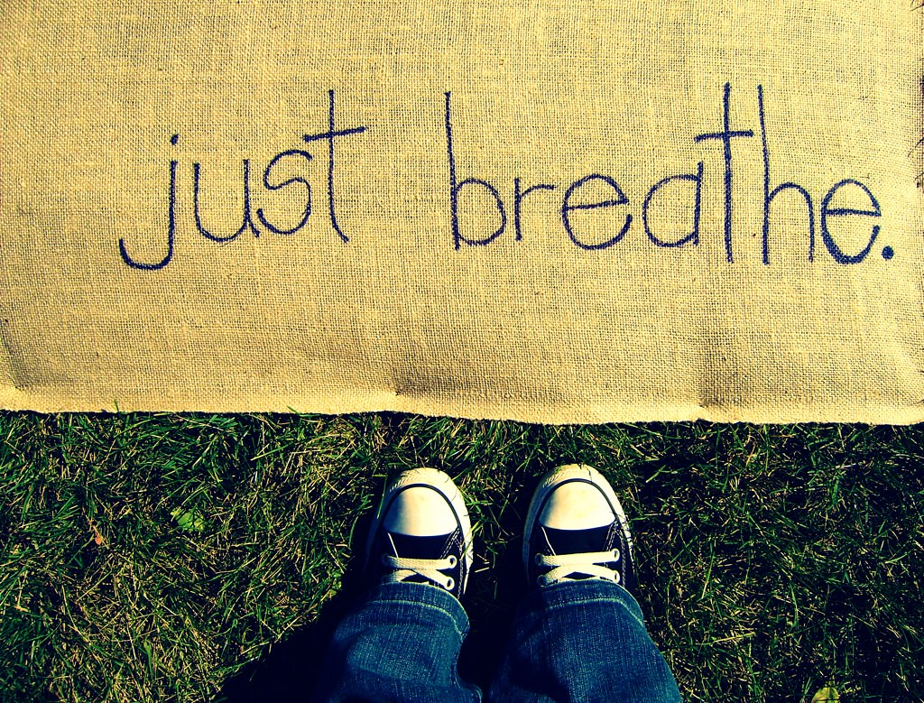

**Friday, June 14**

**7:00am Registration & Continental Breakfast in the Mezzanine**

Breakfast will be in the hotel Mezzanine. This is a hot breakfast that could include Belgian waffles, fruit, biscuits & gravy, and more.

**8:00am- 9:00am Aspire Higher – Stepping up to Leadership (1.0)**

Want to be a leader? Intimidated by leadership? We’ll explore leadership positions that are within reach and how to get there. What are the fears associated with leadership roles? You too can learn to speak in front of others. We’ll discuss the plan for leadership roles internally and externally (e.g., state associations)

**9:00am- 9:15am Break**

**9:15am- 10:45am FPPE and OPPE – Still Crazy after all these Years (1.5)**

Why is the industry still struggling? We’ll discuss the stumbling blocks still out there like process, low volume, data gathering, support and more. We’ll discuss the use of PI findings to market the office/department, describe the link between performance and evidence based privileging with FPPE/PPE/OPPE, and identify challenges and opportunities for a “best practice” compliance process.

**11:00am – 12:00pm Expand Your Horizon – Who Else Credentials and Privileges Besides Hospitals? (1)**

Credentialing/Privileging has become an expansive industry as we know. Opportunities for MSPs have greatly expanded, not only in multiple types of hospitals and non-hospitals, but the virtual world has opened up opportunities as well. This session will describe additional environments such as FQHCs/look a-likes, community health centers, ASCs, tribal clinics, and student health centers to name a few as well as who accredits them; e.g., HRSA, IHS, AAAHC, and more.



**Conference Registration Form**

**Please print or type.**

**Name:**

**Credentials:**  **CPCS**  **CPMSM**  **Other:**

**Title:**

**Company: Hospital MCO Physician Practice Other:**

**Address:**

**City: State: Zip:**

**Phone: Fax:**

**Email:**

**KAMSS Member?**  **Yes**  **No**

**RSVP for Breakfast for those NOT staying at hotel:**

**Thurs:  Yes  No**

**Fri:  Yes  No**

**Registration Fees- Deadline is May11th.**

**KAMSS Member Regular Fee Late Fee**

Thursday and Friday  $200.00  $225.00

Thursday Only  $150.00  $175.00

Friday Only  $100.00  $125.00

**Non-Members**

Thursday and Friday  $225.00  $250.00

Thursday Only  $175.00  $200.00

Friday Only  $125.00  $150.00

**Payment:** Can be done online at **KAMSS.org OR**

Make checks payable to KAMSS

Mail completed registration and payment to:

Leanne Eilert

Mitchell County Hospital Health System

400 W. 8th Street

PO Box 399

Beloit, KS 67420

Benefits and Objective of Attending this Program

9.5 hrs. of CEUs will be applied for by National Association Medical Staff Services

Program topics are beneficial to all medical staff services and credentialing professionals.

Networking opportunities with peers and experts

**Objectives:**

The Medical Staff Services industry is expanding well beyond traditional boundaries. Are you ready for your next opportunity? This exclusive day and a half of educational sessions is dedicated to the development of Medical Services Professionals and Provider Enrollment Professionals. The topics covered include each of the MSP core competency development areas (Personal, Skills and Career). This educational approach is unique to the industry and introduces those new to the field as well as experienced professionals to reevaluate how MSP’s can build and strengthen their talent areas.

Join the collaborative team of experts as they present multiple sessions that will spark your confidence, empower your voice, promote thinking on what can be done to streamline credentialing practices and ensure that privileging and competency systems are not barriers for compliance. Collectively the new ideas, techniques and strategies can become lessons into packaging yourself and talent to achieve greater job satisfaction and success. Throughout this series, attendees will perform classroom exercises to accelerate the learning that can quickly be adapted to individual style – both personally and professionally.

Objectives – by attending this day and a half educational program, participants will be able to:

* Aspire Higher
* Navigate the FPPE/OPPE process
* Expand your horizon as an MSP
* Making Connections
* Navigating how to handle the aging physician
* Medical Staff Governance
* Speak up!

**Hotel Information**

Drury Plaza Hotel Broadview Wichita, 400 West Douglas, Wichita, KS

Reservations must be made separately from conference registration. Reservations can be made either on the website [www.dururyhotels.com](http://www.dururyhotels.com) or by calling 1-800-325-0720 and refer to

Group Number 10069756.

A group of rooms with either 1 King or 2 Queens ($124.00) has been placed on hold for KAMSS. Reservations must be made no later than May11, 2023, to obtain special rate. Visit the hotel’s website [www.druryhotels.com](http://www.druryhotels.com) for additional information.

Check-in is after 3 PM on the day of arrival. Check-out is before 11:00am on the day of departure.

**Amenities:**

Free Hot Quick Start Breakfast starting at 6AM

Free 5:30 Kickback – From 5:30-7:30PM each night, kick back, relax and enjoy a rotating menu of hot foods and cold beverages.

Free long distance

Free Wireless Internet Access

Free Soda and Popcorn from 3 -11PM in the lobby each night

**Information about Wichita and Old Town**

Wichita’s historic old town district is filled with unique restaurants and shops. For information about the old town district, visit their website at [www.oldtownwichita.com](http://www.oldtownwichita.com)

Kansas Star Arena Casino. The casino is about 15 minutes south of the hotel, right off the Kansas Turnpike, Mulvane Interchange. For information about the casino, visit their website at [www.kansasstarcasino.com](http://www.kansasstarcasino.com) or there is a free shuttle leaving from Old Town Farm & Art Market (Thurs, Fri, & Sat) from 6PM to 4 AM – pick-ups at the top of every hour, with returns every half hour. For information about the shuttle, go to [www.kansascasionshuttle.com](http://www.kansascasionshuttle.com)

Wichita’s Museums on the River – There are five 95) museums located along the Arkansas River. For information about the museums, visit their website at <http://www.360wichita.com/Attractions/Museums/MuseumsontheRiver.html>

Shopping – if you would like to visit a larger shopping venue than Old Town –Towne East and Towne West are an option.

For information about what stores are in these malls, go to <http://www.simon.com/search/searchresults.aspx?q=Wichita>



**Directions**

*Traveling West* on Us-400/US54: Take the Central Business District Exit, turn right onto S Main St and turn left onto W Douglas Ave

*Traveling East* on US-400/US-54: Take the Central Business District exit; turn left onto S Main St. turn left onto W Douglas Ave

*Traveling South* on I-135: Take the 2nd St exit (exit 6C) turn right onto E 2nd St N, turn left onto N Hydraulic St, and turn right onto E Douglas Ave

*Traveling North* on I-135: Merge onto US-400/US54 via exit 5B, take the Washington Ave exit, turn right onto S Washington St and turn left onto E Douglas Ave

*Driving directions from airport to hotel*: Take US-400 E/US-54E toward Wichita, take the Seneca exit toward Sycamore, turn left onto S Seneca St, and turn right onto W Douglas Ave

**Attire**

Business casual is appropriate for both days. It is recommended to bring a jacket or sweater due to cooler temperatures in the meeting rooms.

**Conference Courtesy**

Cell phones and pagers should be turned off or moved to vibrate while in session and text messaging is discouraged. Please minimize or refrain from the use of cologne and/or scented products.

**Cancellations/Refunds**

A refund will only be made for cancellations received by the KAMSS Treasurer (either by e-mail or mail) by May 30, 2024. No refunds will be made after this date, except as approved by the Board of Directors. A cancellation fee will be charged to the conference registrant at the discretion of the Board of Directors.

**SPEAKERS**

**Christina W. Giles, MS**

**Co-Founder and Faculty, EDGE-U-CATE, LLC**

**President, C Giles & Associates**

**Nashua, New Hampshire**

**Mathieu Gaulin, CPMSM, CPCS**

**Faculty, EDGE-U-CATE, LLC**

**Senior Director, Professional Medical Staff Services**

**Boston Children’s Hospital**

**Boston, MA**

**Celebrate**

**Please join us in commemorating the 35th anniversary of the Kansas Association of Medical Staff Services. We extend our heartfelt gratitude to our gold level sponsors listed below for their generous support.**

